Nepal college of information Technology

Level: Bachelor | Semester – Fall | Year : 2015
Programme: BE(CE/IT morning) |  | Full Marks: 100
Course: Numerical Methods |  | Pass Marks: 45
 |  | Time : 3hrs.

Candidates are required to give their answers in their own words as far as practicable.
The figures in the margin indicate full marks.

Attempt all the questions.

 | - Find the root of the equation 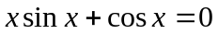 with accuracy 0.008, using secant Position method.  - Using Bisection method find a root of the equation 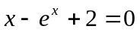correct to three decimal places. | 8  7
 | - Find value of 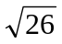 using iteration method.  Estimate the value of sinθ at θ = 55 using Newton divided difference formula with the help of the following table: | 7  8
  θ | 10 | 15 | 25 | 40 | 60
  sinθ | 0.1736 | 0.3420 | 0.5000 | 0.6428 | 0.7660
 | - Determine the constants a and b by the method of least square such that 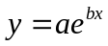 fits the following data:  x : 2 4 6 8 10  y : 1.077 32.084 41.128 92.897 127.62  - Evaluate the integral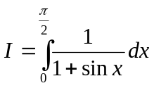. Compare the result in both conditions for Simpson1/3 and 3/8 rule. | 7  8
 | a) Find inverse of the matrix using Gauss elimination method.  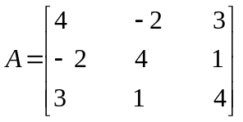  b) Use Gauss seidal method and solve  3x+9y-2z=11  4x+2y+13z=24  4x-4y+3z= -8 | 8  7
 | - Find the value of y at x=0.5 using modified Eular's method, given that dy/dx = x+y² and y=1 at x=0.  - Solve the differential equation for y (0.2) and y’(0.2) using R-K 4th order method. y’’= y + x y’, with y(0) = l and y¹(0) = 0 taking h=0.1. | 8  7
 | - Solve the Poisson equation Uxx + Uyy =6(x² +5xy+2y²) over the square domain 0 ≤ x ≤ 3 and 0 ≤ y ≤ 3 with f = 0 on the boundary and h = 1.  OR(Only For Computer )  Use Factorization method to solve the given system of equation  3x + 2y + z = 10  2x + 3y + 2z = 14  x + 2y + 3z = 14  - Find the largest Eigen values using power method current up to 2-significant digit.  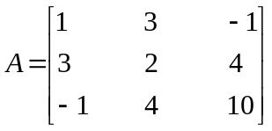 | 8  7
 | Write short notes on any two:  - Least square approximation method  - Convergence of N-R Method.  - Algorithm of Secant Method. | 2×5

